Create a custom docker image for nginx and deploy it using docker compose, where the volume bind mount should be at /var/opt/nginx location. Push the created custom docker image to your docker-hub.

Create a custom docker image from nginx



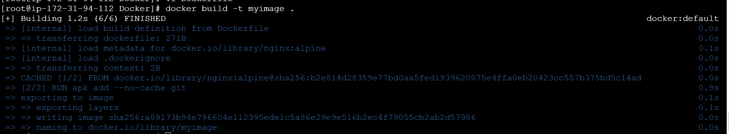



deploy using docker compose, where the volume bind mount should be at /var/opt/nginx location.

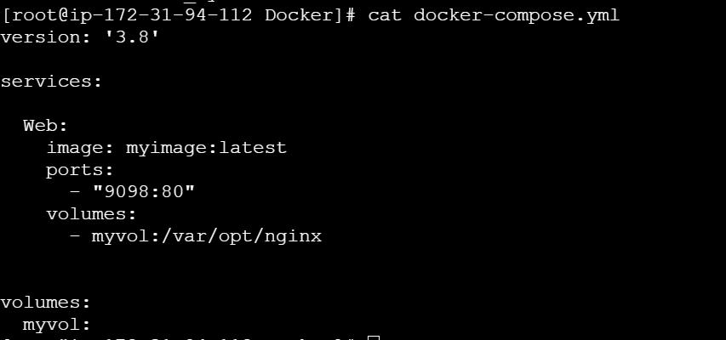



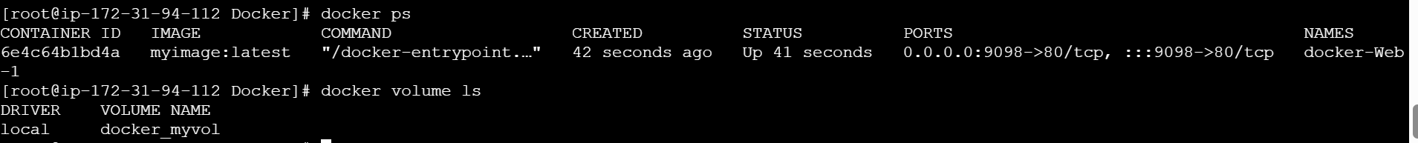



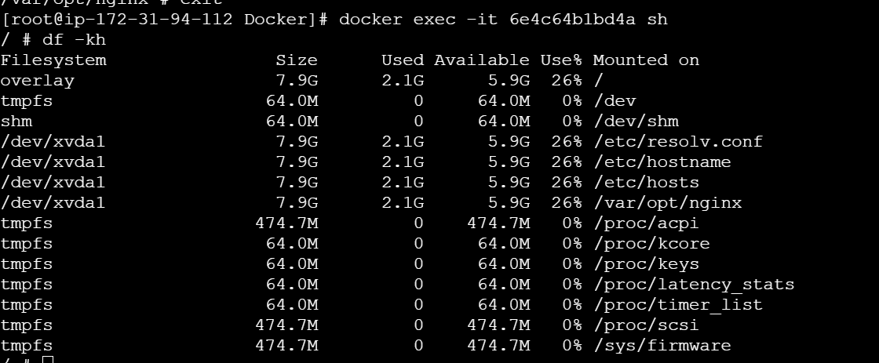



Tag the image

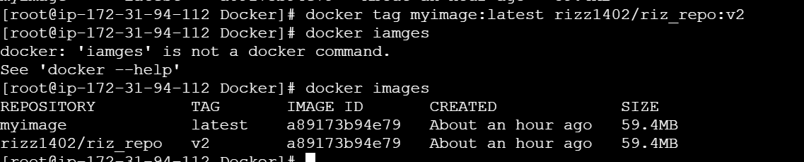

Login to docker

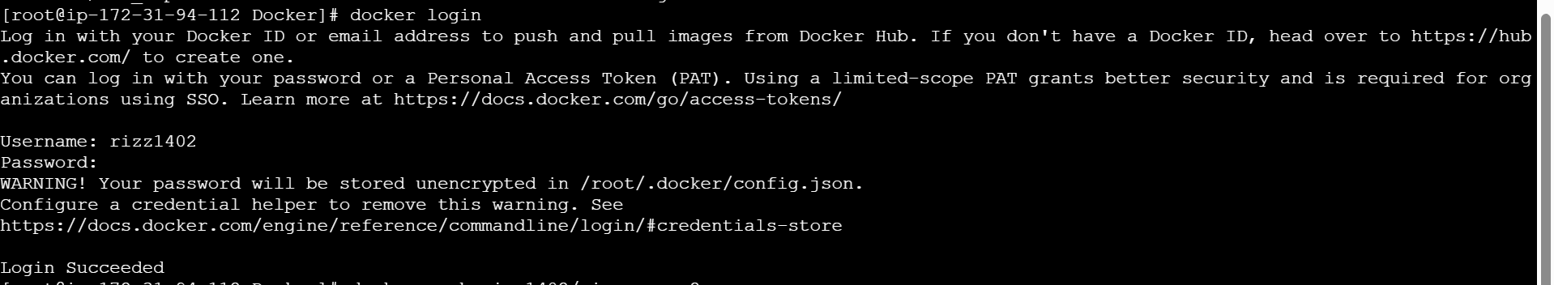

Push the image to docker hub

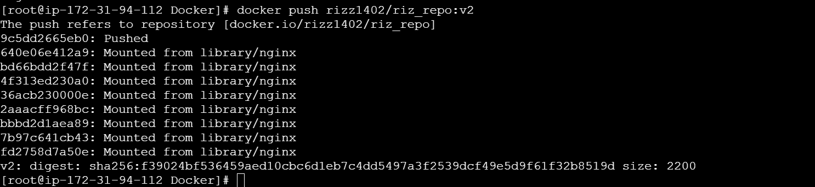

Image uploaded to docker hub

